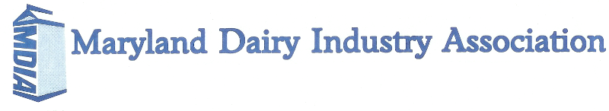

Boyd Cook Memorial Scholarships

Scholarship Awards Program

One $1000 Scholarship
Two $500 Scholarships
MARYLAND DAIRY INDUSTRY ASSOCIATION
BOYD COOK MEMORIAL SCHOLARSHIPS
Offered to MDIA members and their dependents

QUALIFICATIONS:
- Must have MDIA membership for the current year or be a dependent of a member. Contact Laurie Savage for a membership form.
- Available to graduating high school seniors, undergraduate students enrolled in a 2- or 4-year college and graduate/professional school students.
- Applicants can win each award level only once.
- Scholarship will be awarded directly to the student.
- A recent photo and transcript (official or unofficial) must be attached.
- Please TYPE, limit answers to the pages allotted and use 12-point font or you will be disqualified.

PREVIOUS WINNERS:
2008 – Amy Yeiser ($250)
2009 – Tracey Forsythe ($250) and Caitlin Patrick ($250)
2010 – Claybourne Zimmerman ($500) and Samantha Garst ($500)
2011 – Rachel Manning ($500) and Carissa Doody ($500)
2012 – Carissa Doody ($1000), Jason Zimmerman ($500) and Tracey Forsythe ($500)
2013 – Clayborne Zimmerman ($1000), Nicole Hood ($500) and Audrey Ervin ($500)
2014 - Jessica Sentelle ($1000), Ryan Zimmerman ($500) and Lizzie Davis ($500)
2015 - Shelby Hahn ($1000), Julia Doody ($500) and Katelyn Allen ($500)
2016 - Julia Doody ($1000), Ian Doody ($500) and Ben Miller ($500)
2017 - Josiah Manning ($1000), Courtney Hoff ($500) and Autumn Lippy ($500)
2018 - Katelyn Allen ($1000), Todd Allen ($500) and Catherine Savage ($500)
2019 - Catherine Savage ($1000), Lindsay Smith ($500) and Cory Zimmerman ($500)

Please mail completed scholarship applications to:
Laurie Savage
23301 Mount Ephraim Road
Dickerson, MD 20842
Or submit electronically to secretary@marylanddairyindustry.org

Scholarship applications must be postmarked no later than February 19, 2021
MDIA BOYD COOK MEMORIAL SCHOLARSHIPS
APPLICATION FORM

I. GENERAL INFORMATION

Last Name First Name Middle Name

Home Address

City County State and Zip Code

Telephone Number E-mail Address

University or College (Name, city, state) Year at University or College

College Major College Minor Planned Graduation Date

High School Attended (Name, city, state) Date Graduated or Planned

Can we notify your local newspaper of an award? Yes No

Name of Newspaper Street Address

City County State and Zip Code

Family Information:
Father’s Full Name Occupation

Mother’s Full Name Occupation

Siblings (number attending college):

Type of Membership with MDIA: ________________________________________________________
(individual, academic/government/retired, affiliate, sustaining, student)

II. DAIRY AND AGRICULTURAL ORGANIZATIONS
Dairy/breed and other agricultural organizations to which you belong (including leadership roles):

Dairy or agriculture related activities and awards:

III. OTHER ACTIVITIES
School activities and awards:

Church and community activities:

IV. FARM AND WORK EXPERIENCE
Please list your responsibilities working on a dairy farm or in an agriculture-related business:

V. CAREER GOALS

VI. ESSAY
Recently, the audience attending the Golden Globes was served a plant-based meal for what was believed to be better for the planet. The dairy industry, along with others such as the beef industry, are being blamed for producing too much carbon. How would you respond to the Golden Globe audience as to why they should have been served dairy? How is the dairy industry taking steps to reduce their carbon output and improve the environment?

